# Lab 25: Redux with React

## Objectives

*  Refactor the Page (container) component to use React Redux Hooks
*  Refactor the Form component to dispatch an action

## Steps

### Refactor the Page (container) component to use React Redux Hooks

1. Remove the Page (container) component's local state and replace with Redux state using useSelector. Also, get a reference to the Store's dispatch function using useDispatch so we can dispatch actions.

#### src\projects\ProjectsPage.js

Make sure you are in Project**s**Page.js not ProjectPage.js.

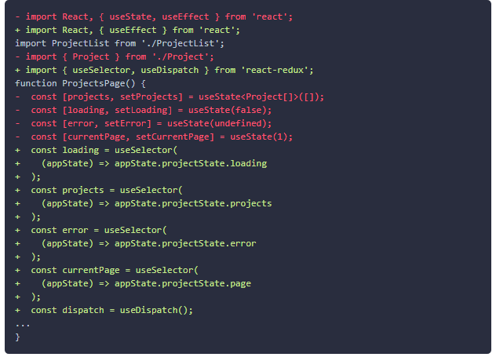

1. Replace state setter function calls and API calls with calls to dispatch passing action creators. Also, remove the onSave function and stop passing it as a prop to the <ProjectList/> component.

#### src\projects\ProjectsPage.js

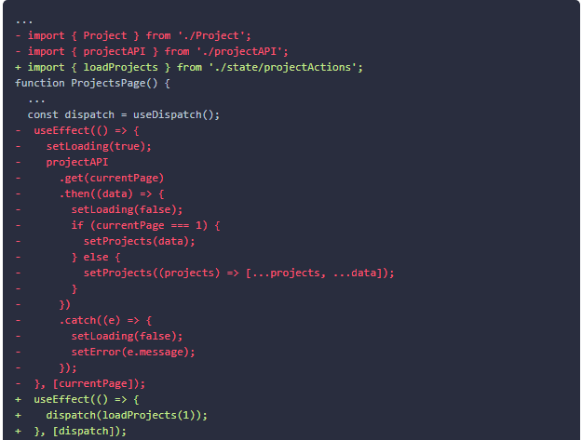

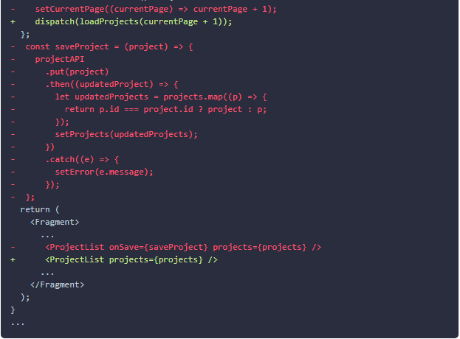

1. Provide the store.

#### src\App.js

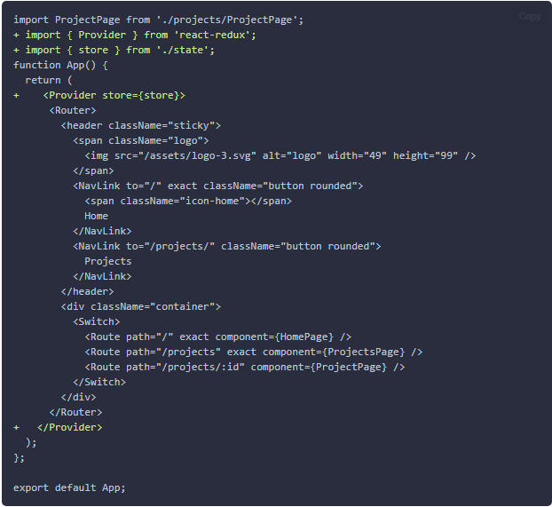

### Refactor the Form component to dispatch an action

1. Refactor the Form component so it dispatches the saveProject action instead of receiving the function as a prop.

#### src\projects\ProjectForm.js

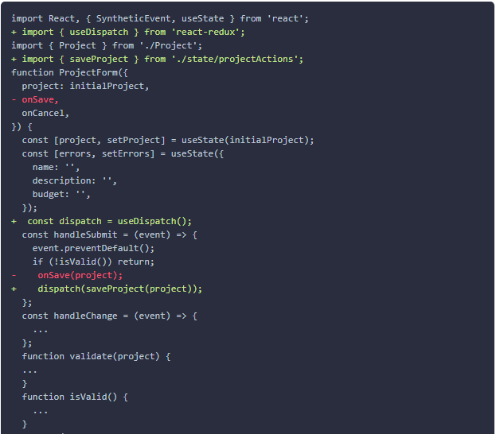

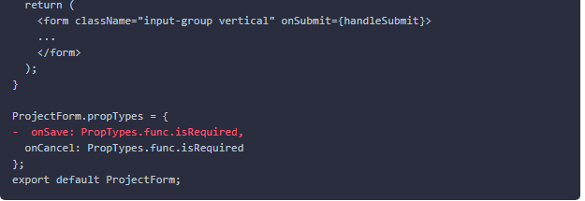

1. Provide the store.

* This was already done in src\App.js because it is inherited from the parent Page component: Page =>List=>Form.

1. In the ProjectList component, remove onSave in the propTypes definition and update the component to not pass onSave to <ProjectForm> as it is now dispatches this action itself after importing it.

#### src\Projects\ProjectList.js

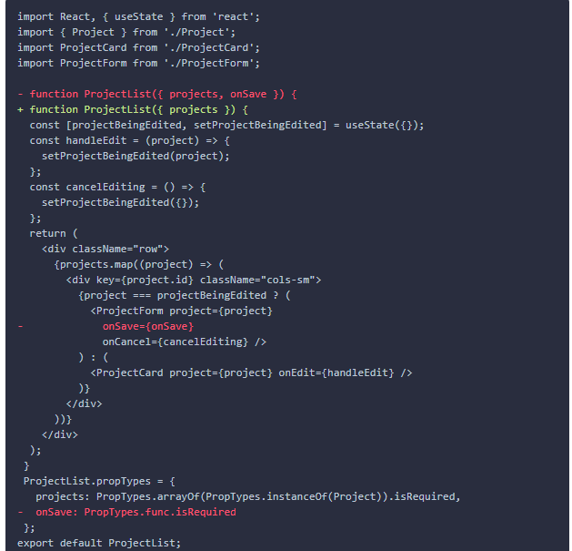

1. **Verify** the application still works including loading and updating the projects.

### ✔ You have completed Lab 25